CREATING A WORK BREAKDOWN STRUCTURE

The Work Breakdown Structure (WBS) is a hierarchical decomposition of the project objectives into deliverable-oriented tasks that are executed by the project team to accomplish the overall project goals. The WBS forms the backbone of all the project planning activities. The WBS divides the scope of the project work into smaller, manageable work packages for maintaining better control of the project activities. As you move from the higher levels of the WBS to the lower levels, the definition of the project works gets more detailed with the upper levels representing the major phases of the project. It is imperative to remember that the WBS represents 100% of all the work defined in the project scope. Anything that is not included in the WBS is considered out of scope for the project.

## Uses of the WBS

The WBS addresses the following requirements of the project:

* Defining the project scope in terms of deliverables and components.
* Providing the framework on which the project status and progress reports are based.
* Facilitating communication regarding the project scope, schedule, risk, performance, cost etc with the stakeholders throughout the project lifecycle.
* Providing inputs for other project management processes like estimation, scheduling, risk assessment, etc.

While creating the WBS, it is important to ensure that the WBS format is standardised across an entire portfolio of projects. This will ensure that data from a specific project can be easily retrieved and a repository comprising project data can be formed for future reference over a period of time.

## Components of the Work Breakdown Structure

The essential components of a WBS are detailed below:

* **WBS Levels:** All the work to be done on the project is categorised into hierarchical levels with the upper levels depicting the major deliverables for the project and the lower levels depicting the granular level activities needed to be performed towards achieving the deliverable. The number and complexity of the WBS levels is dependent on the size and nature of the project.
* **WBS Dictionary:** The WBS dictionary is an important part of the WBS and it further details the activities of each element of the WBS. It provides detailed information about the work to be done, activities, and milestones, cost estimates, resources required, and contract information for each element of the WBS. The basic purpose of the WBS dictionary is to remove any ambiguity regarding the scope of work.
* **WBS Code Numbers:** The WBS code number is a unique identifier for each element of the WBS and should be such that it can be easily expanded to accommodate any future revisions to the WBS.
* **Visual Representation Format:** A WBS can be represented in a number of ways, depending on the ease of use for the project team and the organisation. Typical formats for representing a WBS structure are:
  + **Outline view:** In this format, the WBS is depicted using different levels of indentation, with an accompanying WBS code number for each element.
  + **Tabular view:** In this format, the hierarchical structure of the WBS is represented with the help of the columns of a table.
  + **Tree structure view:** In this format, the WBS is depicted using a tree structure with each child element connected to the parent element through a line. The parent depicts a higher level which is decomposed into the child element.
* **WBS Element:** Each component of the WBS and its attributes comprise a WBS element.
* **Work Package:** The lowest level WBS component for each branch of the WBS is known as the work package. The work package also includes the schedule activities and milestones to be accomplished to complete the work package deliverable. One of the main problems that project managers face while creating a WBS is deciding on the correct size for a work package. A work package that is too big would imply loose control on the activities. Similarly, if the work package is too small, it would consume a lot of effort in managing. The 8/80 rule commonly followed by project managers, propagates that the size of the work package should not be less than 8 hours and not greater than 80 hours.

## Creating a WBS in MS Project Using the Top-Down Methodology

A WBS can be created by using a number of tools and methodologies. One of the commonly used methodologies for creating a WBS is the top-down methodology. The steps followed in the top-down approach are listed below:

1. Identify the final objective of the project. This involves a detailed analysis of the project scope document. In MS Project, type the name of the final objective in the Task Name field.
2. Evaluate the final deliverables that need to be created to achieve the objectives identified in step 1. Enter the list of final deliverables in the Task Name field. Indent all the sub-deliverables by using the forward arrow key in MS Project. Now, you will have the final deliverable comprising the sub-deliverables in MS Project.
3. Decompose the final deliverables into activities and continue this exercise till a level is reached (work package) where you can control and monitor the individual tasks. You should be careful to ensure that each work package contains only one deliverable. In MS Project, for each sub-deliverable, type the list of activities. Repeat this process till you reach the work package level. Make sure that you keep indenting each level. Indentation creates relationships between the deliverables and its component sub-deliverables. MS Project automatically creates the WBS codes in the Outline Number field, based on the outline structure of each task/activity. These outline numbers change when you move the task to a different level or location.
4. Re-evaluate the entire WBS after a thorough brainstorming session with the project team and key stakeholders. The objective should be to achieve a consensus on the feasibility of the success of the project planning exercise which in turn will ensure the success of your project.

The top-down method for creating the WBS is typically used when both the project manager and the project team have inadequate experience in creating the WBS or the project requirements are not thoroughly understood. This method enables the project manager and the team to progressively elaborate on the WBS after several meetings and brainstorming sessions.

## Integration of the WBS in the Project Schedule

The WBS forms the backbone for a number of project management activities. It provides a valuable input for cost estimation, scheduling, and evaluating the progress of the project.

To integrate the WBS in the project schedule using MS Project, you need to add more information to the indented tree-structure of the WBS that you have already created. The important information that you need to add includes:

* **Duration:** The total time required to complete each task needs to be specified in the WBS.
* **Task Dependencies:** The relationship between tasks is specified. You can establish the dependency by using the network diagram analysis done in the scheduling phase.
* **Constraints:** You need to specify the constraints or limitations (if any) for each task. The constraints are also established in the schedule analysis phase.
* **Task Start Date and Task Finish Date:** When you specify the duration for each task, MS Project automatically calculates the Task Start and Finish Dates.
* **Resource Names:** You can specify the resources by clicking the Assign Resources button.

While integrating the WBS in the project plan, it is imperative to add the WBS dictionary. The WBS dictionary helps in integrating other project management processes with the project scope and serves as a useful tool for clarifying the exact project requirements in terms of the scope of work, cost, milestones etc.

A well-defined WBS can be a major contributing factor in ensuring the success of your project. It serves as the key integrating factor between different the project management processes and is considered to be the foundation stone for the project.

## Poor MS Project WBS Example

This WBS is a poor one because there are numerous team members assigned to each of the tasks without a clear definition of who is working on the specific task. When tracking against these tasks, it becomes difficult to understand which team member contributed to the system integration task. When tracking at this level, there is always a detailed discussion around the unlisted tasks that contribute to the overall task. If delays occur, the project manager will have a difficult time explaining why the summary task is late. In larger projects, presenting the project status becomes even more difficult if the project manager doesn’t understand the details behind the work breakdown structure. Below is an example of a poor WBS (Figure 1):

[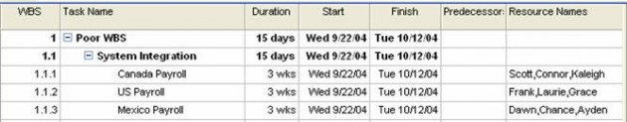](https://www.tacticalprojectmanagement.com/wp-content/uploads/2013/01/msprojectwbs1-e1357186825192.jpg)Figure 1 – Poor WBS Example

## Better MS Project WBS Example

A better approach includes the additional tasks and assigns individual team members to each task as appropriate. It is acceptable to assign multiple resources to the same task as long as the project manager can accurately track the task’s progress by team member. According to PMBOK, the work elements “should be described in terms of tangible, verifiable results in order to facilitate performance measurement” (PMBOK, 1996). Simply put, the WBS needs to be defined at measurable level that specifically and clearly describes the task.

[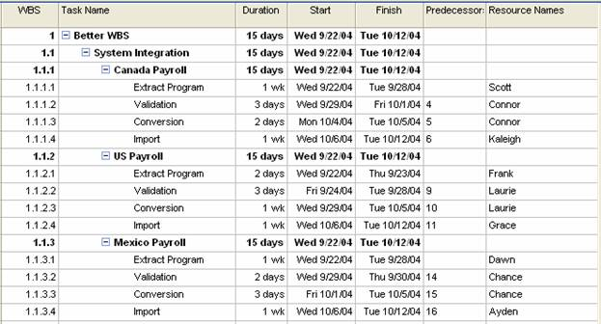](https://www.tacticalprojectmanagement.com/wp-content/uploads/2013/01/msprojectwbs2.jpg)Figure 2 – Better MS Project WBS

In the improved WBS (Figure 2), the summarized project task is dependent upon the subtasks in the project plan. Each sub-task contributes to the overall summary task. Each subtask is uniquely identified and assigned a resource. The plan detail is improved and the project manager can quickly identify the individual tasks by resource. It also holds the team members accountable to the individual deliverables and helps identify any additional dependencies.

It is also helpful to include the Work Breakdown Structure ID in the Gantt chart view. To add the Work Breakdown Structure ID:

1. Select View – Gantt Chart
2. Select Table – Entry
3. Click on the Task Name column or another column
4. Select Insert – Column
5. Select the WBS value
6. Click Ok

By providing detailed subtasks, overall project control is improved. There is no task ambiguity and project team members know who is working on the individual tasks. By decomposing the WBS to “right” level, the project manager can adequately track the work with sufficient control. The “right” level may differ between three to six different WBS levels depending on the process steps and work involved. The project manager should avoid providing too much detail; however, the “right” level is still dependent upon the project.  When the project manager applies resource leveling to the project schedule, it will be easier to level with each task assigned to a single unique resource.